AGENDA
Fish Passage Operation and Maintenance (FPOM) Team meeting
November 14, 2013 (0900-1400)
CRITFC offices. 12th floor.
700 NE Multnomah St., Suite. 1200
Portland, Oregon 97232
Conference line: 888-675-2535 Access/Security code: 4849586

- Approve September 2013 FPOM minutes. (Klatte)

- Action Items
  - NWW Action Items.
    - [Sep 13] LWG Unit 1 return to Kaplan. Conder asked about re-welding the blades at a different angle. Lorz asked for more information on scheduling issues from the Corps. ACTION: D. Weston (Chief of Technical Support Branch) will provide updates at the November FPOM.
  - NWP Action Items. No unresolved action items.
  - Action Items completed or to be discussed later in the agenda.
    - [Sep 13] Snake River temperatures. ACTION: Hevlin will ask Graves to talk to Idaho Power about minimizing releases for five days. STATUS: no update. No longer an issue.
    - [Sep 13] 13BON51. ACTION: the action agencies will bring back an operation that offers as much protection for juveniles and adults that may be attracted to PH2 when operating the PH2 units. STATUS: no update. No longer an issue.
    - [Feb 13] BON AFF PIT tag detector. ACTION: Fryer will have detailed drawings, an operating plan, and monitoring plan for FPOM review in November. STATUS: discussed later in the agenda.

- Updates
  - NWW Updates
    - LWG NSE-1 outage update
    - 13LGS11 PIT tag coordination – work completed on 21 October.
    - 13IHR11 Line 1 disconnect update.
    - MCN Power outage impacts related to passage operations MFR 13 MCN 17
    - MCN update on 13MCN18 November dive
    - NWW winter maintenance – Adult Fish Ladder Schedule.
  - NWP Updates
    - BON Updated Dewatering Plans.
    - BON PH1 ITS status.
      - Forebay elevation and FPP compliance.
    - BON LED testing.
    - JDA BLH Turbine Hub Upgrade Kit
    - NWP winter maintenance schedules are posted to the FPOM site.
  - Research/FFDRWG updates. Approval letters, permits, etc located at www.nwd-wc.usace.army.mil/tmt/documents/FPOM/2010/NWP%20Research/Research.html
  - RCC update.
Project | Previous day average (kcfs) | 5 day forecast average (kcfs) | 10 day forecast average (kcfs)
LWG
MCN
BON
  - Lamprey updates.
  - Avian.
  - Critical Infrastructure.
  - BPA updates.

- FFU Kelt monitoring plan. (FFU)

- AFF PIT tag detector. (J. Fryer). Request from FPOM is preliminary approval for the antennas and location pending a Biomark site visit in late October. PSMFC has raised noise concerns that must be addressed and the exact site must be determined. One issue is where the flume is going to drop fish into the return pool. If the antenna was put downstream of this point, it would record fish that fall back after dropping into the return pool, if put upstream it would record how long it took PIT tagged fish go upstream. As stated in the memo, after the site visit which will determine the exact site and (hopefully) demonstrate no impacts on BO3, CRITFC would come back to FPOM in November with the final design for final approval and then get this installed prior to watering up in 2014.

- Zebra mussel control. (S. Wells)

- TDA ITS gate configuration. (Cordie/Fenton)

- TDA ITS and Fifteen Mile creek steelhead. (Cordie/Faber)

- TDA split flow test. (Cordie/Fredricks)

- Coordination/Notification forms (need concurrence).
  - 13BON89 (updates 13BON05). NWW hydrofoil test in B2CC.
  - 13JDA04 JDA-S two-week extension.
  - 13LWG17 Juvenile Fish Collection Channel Upgrade.

- Fish Passage Plan: The Draft 2014 FPP and Change Forms website is at: http://www.nwd-wc.usace.army.mil/tmt/documents/fpp/2014/changes/index.html. All change forms reviewed to date have been posted. See the “Production Schedule & Deadlines” document for a timeline of events and due dates for change forms to be included the printed version of the 2014 FPP:
- Friday, 01 NOV 2013 – all Corps change forms due to Wright.
- Friday, 13 DEC 2013 – all change forms due to Wright.
- Tuesday, 31 DEC 2013 – final draft sections and change forms will be posted online for regional review.
- Appendix A (Special Project Operations and Studies) sections will be drafted by NWW and NWP as soon as final study designs and operations are finalized (via FFDRWG and/or FPOM), and are due to Wright by mid-February for inclusion in the final print version of the 2014 FPP.

- Potential 2014 FPP changes.
  - Fredricks suggested including a calendar of dates when specific actions are scheduled to occur.
  - MCN: Debris spill protocol prior to TSW removal. Proposed at FPOM June 13.
  - MCN: remove language regarding transportation.
  - MCN: sawtooth model methodology.
  - LGS TSW: add criteria that SW will be closed no earlier than August 1 to ensure closure doesn’t occur during subyearling migration. If low-flow criteria are achieved prior to August 1, the TSW will remain in service until August 1 unless an adult passage delay is observed or if necessary due to turbine unit operational constraints at low flows. Closing the TSW prior to August 1 will be coordinated with FPOM via an MOC.
  - LGS Unit 1 low flow: language to help clarify Unit 1 operation to help push out the back eddy.
  - Appendix B: remove language regarding MCN transport.
  - Lorz asked about the navlock operation at MCN. He wanted to know if the downstream gates are kept closed until needed. There is an idea that the navlock may be the route some sockeye pass without going through the count window. Provide update that gate is stored closed.

- Task Group Updates.
  - Avian task group. Chaired by NWW. Team members include: Cordie, Dugger, Fone, Fredricks, Hausmann, Madson, Setter, Skidmore, Trachtenbarg, Zorich, Zyndol. Next meeting is 20 November at JDA.
  - Sea Lion task group. (Stansell). Team members include: Conder, Cordie, Fredricks, Hausmann, Mackey, J. Skidmore, Whiteaker, VanderLeeuw. The task group met at CRITFC on 18 September.
  - AFF mods (Rerecich). Team members include: Benner, Fredricks, Lorz, Mackey, Meyer, Rerecich, Stephenson, Whiteaker. Team met on 20 August. Rerecich reported the release pipes will be reconnected. Fredricks said he would like to take a look at the head over the exit ladder weirs to make sure there is a streaming flow over them. Valve 15 raking will be looked at as well. Appendix G will be modified to reflect the recommended raking level and the recommended water elevation.
- Calendar items/ next FPOM agenda items. (Check the CY13 on the website)
OFFICIAL COORDINATION REQUEST FOR
NON-ROUTINE OPERATIONS AND MAINTENANCE
☺☺☺☺☺☺☺☺☺☺☺☺☺☺☺☺☺☺☺☺☺☺☺☺☺☺☺☺☺☺☺☺☺☺☺☺☺☺☺☺☺☺☺☺☺☺☺☺☺☺☺☺☺☺☺☺☺☺☺☺☺☺☺☺☺☺☺☺☺☺☺☺☺☺☺☺
COORDINATION TITLE: 13BON B2CC hydrofoil PIT detector test
COORDINATION DATE-14 November 2013
PROJECT- Bonneville Dam
RESPONSE DATE- 14 November 2013 (FPOM)
Description of the problem: The corner collector at the 2nd Powerhouse of Bonneville Dam (B2CC) is an ideal location to field test the proof of concept for a full size hydrofoil PIT-tag system due to existing infrastructure, ease of installation, and cost savings. The B2CC provides existing PIT-tag detection that would enable assessment of the PIT-tag detection efficiency of a hydrofoil PIT-tag detection system. Other surface passage facilities in the Federal Columbia River Power System (FCRPS) lack PIT-tag detection that could be used to assess the detection efficiency of a hydrofoil PIT-tag detection system. Furthermore, the entrance width of the B2CC is 15 feet wide and the entrance to other surface passage structures is 50 feet wide. A smaller width surface passage test environment simplifies the approach and reduces the cost of evaluating the proof of concept prototype. A system that provides coverage for the B2CC would only require 4 hydrofoil antennas where as a system for other surface passage structures such as a Removable Spillway Weir (RSW) would require 18 hydrofoil antennas to provide a similar level of coverage because the width of the entrance is larger. Significant cost savings would result from developing and testing the hydrofoil PIT-tag system concept at B2CC compared to other surface passage structures. If the prototype performs well, the concept may be used to develop PIT-tag detection for a variety of surface passage structures.

The original FPOM request was discussed during the 14 March 2013 meeting for an evaluation during the summer 2013. FPOM concluded the test may go forward as coordinated and the next step was to get approval from Bonneville Project. Sands submitted an access request to the Bonneville project and permission was granted 1 May 2013. Award of a contract was delayed until September 17, 2013 resulting in a need to shift the evaluation schedule. The study comprises a feasibility and compatibility phase followed by an in-water evaluation. The feasibility and compatibility evaluations would include a series of tests at Bonneville Dam and in the laboratory during the fall 2013. These tests would evaluate the hydrofoil concept system feasibility and compatibility with the existing B2CC system in the air and do not include in-water work. The follow up in-water evaluation would be from February to early May 2014.

This MOC is a follow-up request due to changes in the timing of outages.

Type of change in operations required: Four periods of change in operation of the B2CC are requested, short periods of B2CC operation in early February 2014, begin operation of B2CC by 0800 on March 17, 2014 if not already operating, and two outages of up to 8-hours each on April 8, 2014 and May 13, 2014 (Table 1). The project schedule is summarized in Table 2.
Table 1. Tentative changes in the operation of the B2CC in the Fish Passage Plan required for the evaluation.
Approximate Dates | Operational Change | Activity
~Feb. 3-14 | Periodic operation | Installation, counter weight adjustment and orientation of the hydrofoil antennas.
March 17, 2014 0800 | Open B2CC | Begin continuous operation of B2CC if not already operating.
early April  (~April 8, 2014) | Up to an 8-hour outage | Remove hydrofoil PIT-tag antennas.
early May  (~May 13, 2014) | Up to an 8-hour outage | Remove monitoring equipment (DIDSON camera and equipment barge).

Table 2. Tentative project schedule.
Dates | Activity
September 17, 2013 | Contract awarded.
October 16, 2013 | Pre-work coordination meeting.
October 28-31, 2013 | Feasibility test to assess compatibility and/or interference issues between an unshielded hydrofoil concept system and existing B2CC PIT-tag detection system.
February 2014 | Install prototype forebay PIT-tag antennas and monitoring equipment
 | (DIDSON cameras and equipment barge).
Begin between March 1 and March 17 and continue through April 7, 2014 | Evaluate the B2CC passage distribution with the prototype forebay PIT-tag detection system installed and B2CC operating (treatment test condition). Evaluate the physical performance of the prototype forebay PIT-tag detection system.
April 3-7, 2014 | Test debris response of hydrofoil antennas.
April 8, 2014 | Remove prototype forebay PIT-tag detection system.
April 9-May12, 2014 | Evaluate the B2CC passage distribution without the prototype forebay PIT-tag detection system installed (control test condition).
May13, 2014 | Remove monitoring equipment (DIDSON cameras and equipment barge).

We request intermittent operation of the B2CC to facilitate adjustment and orientation of the hydrofoil antennas during installation during early February 2014. B2CC would need to be opened and closed several times a day over approximately a 5 day period to determine the amount of counter weight and orientation of each hydrofoil as they are sequentially installed.

The draft Fish Passage Plan calls for the B2CC to operate during spill season and this is dependent on meeting a target of kelts at the JMF adult/debris separator with the count beginning on March 01. The tentative target is 2 kelts per day are observed at the JMF separators for 2 consecutive days for a cumulative total of 20 kelts which begins operation of the B2CC for the fish passage season. For the period of 2009 to 2013 the B2CC was opened between March 1 and April 13 and the kelts target was reached between March 14 and April 13 (Table 3). We request that if the kelts target has not been reached by 0800 on March 17, 2014 the B2CC would become operational on March 17, 2014 at 0800.

Table 3. Date of initial operation of B2CC and date kelts target was reached, 2009-2013.
Year | B2CC Opened | Reached kelts target | Notes
2013 | 1-Mar | 22-Mar | Closed 3/13 and reopened 3/22
2012 | 19-Mar | 19-Mar
2011 | 14-Mar | 14-Mar
2010 | 17-Mar | 25-Mar | Closed 3/23 and reopened 3/25
2009 | 13-Apr | 13-Apr

Closure of the B2CC would be required for removal of the hydrofoil PIT-tag antennas in early April (approximately April 8, 2014) and a second outage in early May (approximately May 13, 2014) to remove monitoring equipment (DIDSON cameras and an equipment barge) (Figure 1). It is expected that each of the outages would require no more than 8-hours to complete.

Impact on facility operation: The installation of monitoring equipment and open and closure of the B2CC will require operational support from the project. Project crane assistance for the installation and removal of monitoring equipment and the prototype forebay PIT-tag detection system will be coordinated with the project. Access to the intake area of the B2CC will be needed by the contractor on a regular basis between October 2013 and May 2014. Access to the BRZ in the vicinity of the B2CC will be needed for monitoring equipment installation and testing. Outages to the B2CC will be required to safely remove equipment. Table 2 is a tentative schedule for major study activities study.

Length of time for repairs: N/A

Expected impacts on fish passage: Installation of equipment will occur prior to the fish passage season and should not affect fish passage. Removal of equipment will occur during the fish passage season.

B2CC outages to remove equipment will temporarily increase the number of fish passing through turbines and the juvenile bypass system and may affect smolt survival. Potential impact to migrating yearling Chinook salmon, coho salmon, sockeye salmon and steelhead smolts and steelhead kelt have been estimated (See Tables 3-8).

The intermittent operation of the B2CC for orientation adjustment of the hydrofoil antennas during installation in early February is not anticipated to negatively impact smolt passage.

The potential operation of the B2CC prior to reaching the kelt target in the FPP is not anticipated to negatively impact smolt passage.

There is no anticipated impact to other studies at Bonneville Dam from February to May 2014. In the event that other studies are conducted at B2CC from February to May 2014 activities will be coordinated to minimize impacts.

Affects of B2CC 8-hour outages in early April and early May:
Smolt Passage
Each outage would be up to 8 hours but may be less than 8 hours. B2CC outages would be on April 8 and May 13. The overall impact to ESA listed smolts was estimated by applying the passage proportions and survival estimates from the Compass Model to the range and average daily smolt passage index (from Fish Passage Center) estimated during the previous 5 years (2009 to 2013). The outage impact to ESA listed smolts was estimated using the NOAA Fisheries 2012 “Estimation of Percentages for Listed Pacific Salmon and Steelhead Smolts Arriving at Various Locations in the Columbia River Basin”. Assumptions used for assessing the impact to smolts included: 1) passage distribution is similar across the day, 2) each 8-hour outage represents 1/3 of the daily passage numbers, 3) the B2CC outage would affect passage distribution only for the 2nd powerhouse, 4) Compass Model passage distribution and survival for Coho and sockeye salmon were assumed to be the same as yearling Chinook salmon. Compass Model estimates and calculated assumptions are presented in Table 4. Numbers of affected smolts and additional mortality (overall and ESA listed fish) for each 8-hour closures of the B2CC are presented in Tables 5 and 6, and overall in Table 7.

Table 4. Assumptions by species used to estimate the impact of closing the B2CC on smolts. The B2CC outage is anticipated to affect passage distribution for the 2nd powerhouse only.
 | subyearling Chinook | Yearling Chinook | Coho | Sockeye | Steelhead
B2CC survival | 99.0% | 100.0% | 100.0% | 100.0% | 100.0%
B2 Turbine survival | 86.0% | 94.8% | 94.8% | 94.8% | 87.9%
JBS survival | 95.5% | 98.0% | 98.0% | 98.0% | 95.4%
B2CC Operating
B2CC passage | 44.4% | 32.5% | 32.5% | 32.5% | 70.7%
B2 Turbine passage | 41.7% | 43.8% | 43.8% | 43.8% | 15.0%
JBS passage | 13.9% | 23.7% | 23.7% | 23.7% | 14.3%
B2 survival | 93.1% | 97.3% | 97.3% | 97.3% | 97.6%
B2CC Closed
B2 Turbine passage | 75.0% | 65.0% | 65.0% | 65.0% | 17.0%
JBS passage | 25.0% | 35.0% | 35.0% | 35.0% | 83.0%
B2 survival | 88.4% | 95.9% | 95.9% | 95.9% | 94.1%
Change in B2 survival | -4.7% | -1.3% | -1.3% | -1.3% | -3.4%
% ESA listed | 37.7% | 15.5% | 1.5% | 0.9% | 72.4%
Change in ESA listed survival | -1.8% | -0.2% | 0.0% | 0.0% | -2.5%

Table 5. Estimated Bonneville Dam smolt passage and additional mortality resulting from closing the B2CC for 8-hours on April 8 (passage was for the 5-year period 2009-2013).
 | subyearling Chinook | Yearling Chinook | Coho | Sockeye | Steelhead
Dam passage (2009-2013) | 359 to 3,375 | 297 to 1,525 | 96 to 8,059 | 0 to 93 | 109 to 590
B2CC passage in 24h | 80 to 756 | 56 to 285 | 18 to 1,507 | 0 to 17 | 46 to 248
B2CC passage in 8h (affected) | 27 to 252 | 19 to 95 | 6 to 502 | 0 to 6 | 15 to 83
Estimated additional mortality | 1 to 12 | 0 to 1 | 0 to 7 | 0 | 1 to 3
Estimated additional mortality  (ESA listed) | 0 to 4 | 0 | 0 | 0 | 0 to 2

Table 6. Estimated Bonneville Dam smolt passage and additional mortality resulting from closing the B2CC for 8-hours on May 13 (passage was for the 5-year period 2009-2013).
 | subyearling Chinook | Yearling Chinook | Coho | Sockeye | Steelhead
Dam passage (2009-2013) | 403 to 427,190 | 47,858 to 152,162 | 8,688 to 22,778 | 1,474 to 55,150 | 5,636 to 36,960
B2CC passage in 24h | 90 to 95,691 | 8,949 to 28,454 | 1,625 to 4,259 | 276 to 10,313 | 2,367 to 15,523
B2CC passage in 8 hours (affected) | 30 to 31,897 | 2,983 to 9,485 | 542 to 1,420 | 92 to 3,438 | 789 to 5,174
Estimated additional mortality | 1 to 1,505 | 40 to 126 | 7 to 19 | 1 to 46 | 27 to 178
Estimated additional mortality  (ESA listed) | 1 to 567 | 6 to 20 | 0 | 0 | 20 to 129

Table 7. Overall estimate of number of smolts affected and additional smolt mortality resulting from closing the B2CC for up to 8-hours each day on April 8 and May 13.
 | subyearling Chinook | Yearling Chinook | Coho | Sockeye | Steelhead
B2CC passage in 8 hours (affected) | 57 to 32,149 | 3,002 to 9,580 | 548 to 1,922 | 92 to 3,443 | 804 to 5,257
Estimated additional mortality | 3 to 1,517 | 40 to 127 | 7 to 25 | 1 to 46 | 28 to 181
Estimated additional mortality (ESA listed) | 1 to 572 | 6 to 20 | 0 | 0 | 20 to 131

Kelts and Adult Salmon Passage
Each outage would be up to 8 hours but may be less than 8 hours. B2CC outages would be on April 8 and May 13. The overall impact to steelhead kelts and adults was estimated by applying the passage distribution and survival estimates from the report titled Route-Specific Passage and Survival of Steelhead Kelts at the Dalles and Bonneville Dams, 2012 by Rayamajhi et al. 2013. The numbers of kelts and adults that may be affected by the proposed 8 hour B2CC outages on April 8 and May 13 was estimated from the monthly counts of kelts and adults observed on the Bonneville Powerhouse separator during the previous 5 years (2008 to 2012; Rick Martinson, PSMFC, personal communication). Approximately 75% of the adults that cross the separator are observed (Rick Martinson, PSMFC, personal communication), so the monthly counts were adjusted up for approximately 25% that are not observed. Daily passage numbers were not available so daily passage numbers were estimated as the daily portion of the monthly total count. Assumptions used for assessing the impact to kelts and adults included: 1) passage distribution is similar across the day (Weiland et al. 2009 did not observe a diel passage pattern), 2) each 8-hour outage represents 1/3 of the daily passage numbers, 3) the B2CC outage would affect passage distribution only for the 2nd powerhouse, 4) passage distribution and survival was assumed similar for kelts and adults salmon. Passage and survival estimates and calculated assumptions are presented in Table 8. Numbers of affected kelts and adults and additional mortality for an 8-hour closure of the B2CC on April 8, May 13 and overall are presented in Table 9.

Table 8. Assumptions used to estimate the impact of closing the B2CC on steelhead kelt or adult salmon. The B2CC outage is anticipated to affect passage distribution for the 2nd powerhouse only.
 | Steelhead kelt and adult salmon
B2CC survival | 95.0%
B2 Turbine survival | 60.0%
JBS survival | 60.0%
B2CC Operating
B2CC passage | 74.4%
B2 Turbine passage | 12.8%
JBS passage | 12.8%
B2 survival | 86.0%
B2CC Closed
B2 Turbine passage | 50.0%
JBS passage | 50.0%
B2 survival | 77.4%
Change in B2 survival | -8.6%

Table 9. Estimated numbers of steelhead kelts and adult salmon that may be affected and additional mortality resulting from closing the B2CC for 8-hours on April 8, May 13, and overall (passage numbers are estimated from 2008-2012).
 | April 8 |  | May 13 |  | Total
 | Kelts | Adults | Kelts | Adults | Kelts | Adults
Estimated B2CC passage 24h | 0 to 1 | 4 to 41 | 0 to 2 | 4 to 176 | 0 to 3 | 8 to 217
Estimated B2CC passage 8h (affected) | 0 | 1 to 14 | 0 to 1 | 1 to 59 | 0 to 1 | 1 to 73
Estimated additional mortality | 0 | 0 to 1 | 0 | 0 to 5 | 0 | 0 to 6

Comments from agencies:
14 March 2013 FPOM- 13BON05 B2CC hydrofoil PIT detector test. (Attached). Laughery provided a .ppt presentation. Installation will require the B2CC be closed for two days. Laughery is looking at an ERDC trip in April to look at the TSW model. Sands submitted a request for access request letter to BON. NWW is waiting on approval from BON before going forward with the contracting to start fabrication and installation. Fredricks said there is the coordination that is occurring today and then further coordination regarding details about timing and deployment. Hausmann said the BON concerns are primarily debris and the impact to the slot filler. Currently there is not a good way to free debris since it is very rare that anything gets hung up at the B2CC. CRITFC is ok with the installation as long as it doesn’t significantly impact B2CC operations. Hevlin thanks Fredricks for working out the bugs on this project in NWP rather than at LWG. Fredricks said he figured it would impact less fish at the B2CC than at a TSW at LWG. Fredricks also noted that this test is scheduled for a time when sub-yearlings pass and sub-yearlings do not use the B2CC as much as the spring fish. There will not be any additional fish tagged to pass through this system. FPOM is in agreement with moving this test forward

Final results:

Figure 1. Equipment barge for monitoring B2CC passage using DIDSON cameras. Photos are from a study conducted in 2008.
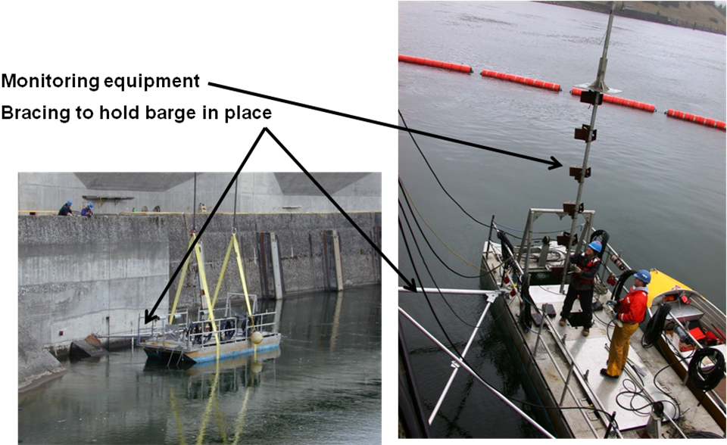
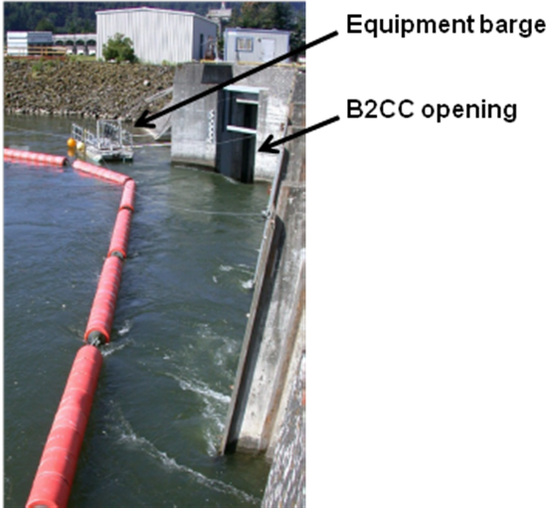
Figure 2. Plan view of hydrofoils and Figure 3. Section view of hydrofoils
frame mounted to B2CC slot filler. rotated to B2CC closure gate.
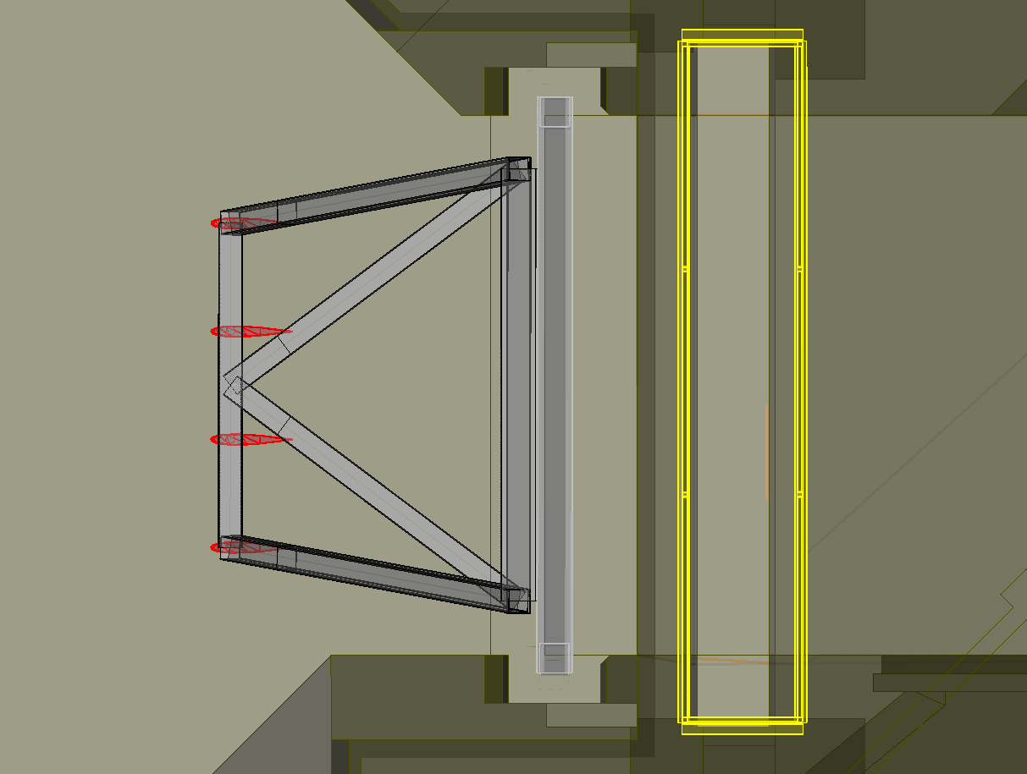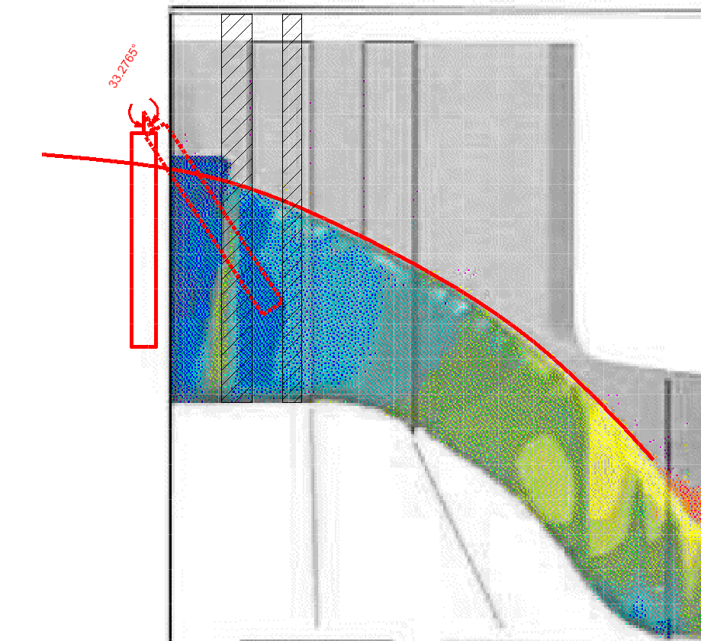
Closure Gate Slot
New Support Frame Attached to Slot Fillers
☺☺☺☺☺☺☺☺☺☺☺☺☺☺☺☺☺☺☺☺☺☺☺☺☺☺☺☺☺☺☺☺☺☺☺☺☺☺☺☺☺☺☺☺☺☺☺☺☺☺☺☺☺☺☺☺☺☺☺☺☺☺☺☺☺☺☺☺☺☺
COORDINATION TITLE- 13JDA04 John Day Dam South Adult Fishway’s extended outage for Joint and Waterstop Repair
COORDINATION DATE- 8/13/13
PROJECT- John Day Dam, Natalie Richards, District PM & Miro Zyndol, JD POC
RESPONSE DATE- October 2013 FPOM
Description of the problem- Failed waterstops in several parts of the JDA have resulted in the water leaking into galleries and onto electrical equipment, creating a safety hazard. A critical part of this large repair contract is the JDA-S Fishway AWS conduit, leaking into the PH Strainer Gallery (floor 1)

The repair is attaching a rubber seal to the concrete with stainless steel plate and stainless steel expansion anchors. There will also be an odorless elastomeric sealant placed under the rubber seal to insure a good watertight seal.

Type of outage required- JDA-S Fishway is required to be OOS and the AWS conduit must be dewatered/ dry to facilitate access to all repair/work areas along the length of JD Powerhouse.

The repair is attaching a rubber seal to the concrete with stainless steel plate and stainless steel expansion anchors. There will also be an odorless elastomeric sealant placed under the rubber seal to insure a good watertight seal.

Impact on facility operation – The FPP has 1 March as the start date for all fishways. JDA-S Fishway will be OOS through 8 March 2014. JDA will return the fishway to normal operation no later than 15 March.

Since the repair is attaching a rubber seal to the concrete with stainless steel plate and stainless steel expansion anchors and using an odorless elastomeric sealant, there is no need for flushing the fishway prior to returning to service.

Dates of impacts/repairs- Mid-January 2014 through 15 March 2014.

Length of time for repairs- About two months, from mid January through 8 March. JDA-S Fishway will return to regular service the week of 10 March, with everything in FPP criteria no later than 15 March 2014.

Expected impacts on fish passage-
Bull Trout- This action is expected to have minimal impacts to Bull Trout.
Occurrence in Action Area. Of the five distinct population segments (DPS) of bull trout listed as threatened by the USFWS, the Columbia River DPS is the only one that is likely to occur in the vicinity of the proposed project. Historically, bull trout of the Columbia River DPS likely ranged through much of the Columbia River Basin with spawning and rearing occurring in the coldest creeks, often at higher elevations. Presently, bull trout of the Columbia River DPS are distributed in a more fragmented pattern throughout the Columbia River Basin with fewer adult migratory fish and fewer, more compressed spawning reaches than historically occurred.

WDFW and Corps personnel provided a list of anecdotal sightings/captures of bull trout in the mainstem Columbia River. From 2000 through 2012 there were eleven bull trout reported. Three were downstream of Bonneville Dam, with two at the mouth of Hamilton Creek (RM 143) and one in 2005 at the Bonneville Dam Smolt Monitoring Facility (RM 144). Upstream of the dam, one bull trout was found at Cascade Locks (RM 149), two at Drano Lake (RM 162), two at the mouth of the Klickatat River (RM 180.5), one in 2002 at the John Day Dam Smolt Monitoring Facility (RM 215), and one sighting at Dog Creek Falls by a reputable WDFW creel sampler who observed 18- to 24-inch cuts or dollies working old redds below the splash pool over the course of two weeks.

Lamprey- no expected impacts due to timing of the outage does not coincide with historical timing of adult lamprey passage.

Downstream migrants- The outage is for the adult fishway, the juvenile bypass system will operate within FPP criteria.

Upstream migrating salmonids- Minimal impact expected for Chinook, due to their timing doesn’t typically coincide with the proposed extended outage. There are impacts expected for steelhead. The majority of steelhead tend to pass JDA-S during March. These fish may be delayed as they seek the JDA-N entrance. Providing attraction flow may help alleviate these impacts, however, looking at October passage for steelhead, by ladder, for the years 2008-2012, 1.5K of attraction flow normally provided by Bay 2 may not be enough to pull the majority of the fish to JDA-N.

Table 1. JDA Steelhead passage, by ladder, from 1-31 October 2008-2012.

Table 2. JDA Steelhead and Chinook passage from 4-31 March for years 2003-2007.

Comments from agencies
12 September 2013- FPOM asked if there are residues that need to be washed out prior to watering up the fishway.

JDA Tech Staff- -----Original Message-----
From: Hunter, Patrick J NWP
Sent: Thursday, September 12, 2013 10:12 PM
To: Mackey, Tammy M NWP; Richards, Natalie A NWP
NWP; Zyndol, Miroslaw A NWP
Subject: RE: 13JDA04 JDA-S extended outage (UNCLASSIFIED)

Classification: UNCLASSIFIED
Caveats: NONE
We should check with the designers but I saw they were using a product that met standards for drinking water and the same standards we use for grouts to repair the leaking joints in the fish ladders.
Patrick J. Hunter, P.E.

CENWP-EC-DS-
-----Original Message-----
From: Hace, Kevin J NWP
Sent: Tuesday, September 17, 2013 10:06 AM
To: Richards, Natalie A NWP; Zyndol, Miroslaw A NWP
Subject: Grout (UNCLASSIFIED)

Classification: UNCLASSIFIED
Caveats: NONE

For repairs in the fishway and in the AWS conduit, there is no grout that will be placed.
The repair is attaching a rubber seal to the concrete with stainless steel plate and stainless steel expansion anchors.
The detail also calls for an odorless elastomeric sealant to be placed under the rubber seal to insure a good watertight seal.

No grout is called out in this repair.
Kevin

NOAA Fisheries-
-----Original Message-----
From: Gary Fredricks - NOAA Federal [mailto:gary.fredricks@noaa.gov]
Sent: Tuesday, September 17, 2013 2:14 PM
To: Mackey, Tammy M NWP
Cc: Trevor Conder - NOAA Federal; Kiefer,Russell; Lorz, Tom
Subject: [EXTERNAL] Re: FPOM: 13JDA04 JDA-S two week extended outage (UNCLASSIFIED)

Tammy, I see the response on the "odorless" sealant but I have to wonder if this is odorless to humans (relatively poor sense of smell) or salmon that have an extremely fine tuned sense of smell. In any case, I think this work poses a significant risk to overwintering steelhead that are moving towards their spawning areas at this time of the year. We seem to be experiencing another rather poor run this year, particularly the later, largely "B" run fish and we don't need additional passage effects that might make things worse. To help alleviate delay, I would recommend sufficient attraction spill for the north ladder during the days in March when the south ladder is out of service. Thanks, Gary

JDA Fisheries-----Original Message-----
From: Zyndol, Miroslaw A NWP
Sent: Tuesday, September 24, 2013 3:44 PM
To: Mackey, Tammy M NWP; Richards, Natalie A NWP; Hace, Kevin J NWP; Green, Allen NWP; Hunter, Patrick J NWP
Cc: Grosvenor, Eric NWP; Klatte, Bernard A NWP; Wertheimer, Robert H NWP; Tackley, Sean C NWP; Stansell, Robert J NWP
Subject: RE: 13JDA04 JDA-S extended outage in March 2014 (UNCLASSIFIED)

Classification: UNCLASSIFIED
Caveats: NONE

I am only aware of a study for "no attraction spill versus 1.5 K" by FFU, which resulted in the current JD requirement; there isn't any experimental evidence that an additional flow would attract more fish to JD North entrance.

Also, the available fish passage data seem to indicate a different passage preference by various species of adult salmonids. For example, fall chinook prefer JD South over JD North at 3:1 ration, while fall steelhead are close to the ideal 1:1 distribution.

In summary, the only proven attraction spill for bringing more adult salmonids to the JD North entrance is 1.5K.
Thanks !
MZ
PM-E. -----Original Message-----
From: Langeslay, Mike J NWP
Sent: Tuesday, November 05, 2013 3:04 PM
Subject: RE: FPOM: Official Coordination- 13JDA04 JDA-S extended outage (UNCLASSIFIED)
Classification: UNCLASSIFIED
Caveats: NONE
Tammy, probably the most current source of empirical data for this is the U of I telemetry study we did in the fall of 1997. I pasted the conclusions below but it might get jumbled. In case you didn't already have this, the report is attached. There may be some older reports that apply, but we did this study specifically to address this issue.

"We found little evidence that spill at levels used during the 1997 study significantly improved passage for steelhead at John Day Dam. There were no significant differences in use of the NSE nor were there significant differences in median passage times for steelhead that first approached and first entered NSE and passed the dam using the north-shore ladder with and without spill. The proportion of steelhead that first approached and first entered NSE, and that eventually passed the dam using the north-shore ladder was consistently higher during spill periods than during periods without spill, but differences were not statistically significant. Nearly half the steelhead first entered the tailrace at John Day Dam along the north shore, but only 16-17 % first approached the dam at the north-shore fishway. Spill levels during this study were about 1% of river flow, with the remaining flow passing through the powerhouse near the southern shore. The level of spill used during this study was insufficient to counter the attractive flow coming from the powerhouse. Columbia River flows were also above average in 1997. Effects of spill during summer and early fall on passage of steelhead at John Day Dam during low flow years may vary from that observed during this study."

Final results
☺☺☺☺☺☺☺☺☺☺☺☺☺☺☺☺☺☺☺☺☺☺☺☺☺☺☺☺☺☺☺☺☺☺☺☺☺☺☺☺☺☺☺☺☺☺☺☺☺☺☺☺☺☺☺☺☺☺☺☺☺☺☺☺☺☺☺☺☺☺
COORDINATION TITLE- 13LWG17 Lower Granite Juvenile Fish Collection Channel Upgrades
COORDINATION DATE- initially September 10, 2013;recoordinate November 14, 2013
PROJECT- Lower Granite
RESPONSE DATE- November 14 FPOM meeting
Description of the problem- Construction activities associated with the Lower Granite fish bypass system upgrade will require extensive onsite efforts over an approximate 36 to 86 month construction schedule. While many of the construction activities can occur during normal project operations, some activities may require alteration of normal project operations. The time necessary for completion of construction activities will be directly correlated with the construction methods employed. The existing collection channel within the powerhouse will require extensive concrete mining to expand the channel from 6 ft. to 9.5 ft. and the potential replacement of 10” orifices with 14”orifices. The construction method for concrete mining has yet to be determined but the USACE is approximating 6-10 months to complete the task which likely translates into three un-watered work windows (15 December to 24 March). On the other end of the spectrum for construction schedules, a single un-watered work window of 1 August to 24 March is anticipated to allow for construction activities without interruption and benefit the collection mining process. All potentially anticipated construction scenarios have various pros and cons on project operations, fish passage, and overall project costs.

The USACE’s Fish Passage Plan (2013) calls for the collection channel to be operated from 25 March to 31 October for juvenile passage and collection and 1 November to 15 December for adult fallback passage. Spill operations typically begin 3 April and end 31 August. The proposed extended un-watered work window would alter the normal operations of the collection channel and as a result limit the available passage routes to the spillway and turbines during the month of August. Available passage route for September to December would be via the turbines. The Corps proposes that the RSW operate from 1 September to 15 December to allow alternate passage routes for juvenile and adult salmonids. The RSW would operate under the following scenario:

- Operate the RSW 12 hours per day (6am to 6pm) from 1 September to 15 December.

Operating the RSW during the extended un-watered work window would require discharge through the RSW of 6.8 kcfs. During low to average river flow years, minimum generation requirements through the turbines may result in a lack of water to operate the RSW and maintain minimum operating pool. In that case, the RSW would need to be closed and flows would be routed through the turbines while maintain minimum operating pool levels.

Table 1. – Average inflows and turbine discharge at Lower Granite Dam, 2006 to 2012. Inflow and powerhouse discharge are reported as kcfs.
Month | Inflow (kcfs) | Powerhouse (kcfs)
August | 31.05 | 13.20
September | 24.77 | 23.95
October | 21.07 | 20.60
November | 21.73 | 20.70
December | 24.03 | 23.65

Type of outage required- The removal of ESBS’s and the closure of the collection channel from 1 August 2015 to 24 March 2016. Open the RSW for fish passage from 1 September to 15 December.
Impact on facility operation- The impact to facility is the early closure of the collection channel and the de-watering of the Juvenile Fish Facility in August 2015 instead of normal December closure.
Dates of impacts/repairs- 1 August 2015 to 24 March 2016
Length of time for repairs- The construction of the Juvenile Bypass System is anticipated to begin in the fall of 2014 with completion in the spring of 2016. The extended un-watered work window is expected to occur from 1 August 2015 to 24 March 2016.
Expected impacts on fish passage- The closure of the collection channel may impact juvenile salmonids passage and transportation (Table 2) and adult fallbacks (Table 3) and require their passage through the spillway, RSW or turbines. Fish that are entrained in the gatewells will need to be dipped out and transported to the boat ramp for release downstream of the dam. After the initial dipping effort, project personnel will monitor the gatewells for signs of fish problems during the extended work window. This will require additional staff time for both JFF staff and Smolt Monitoring staff.

Table 2. – Juvenile salmonid collection and transportation at Lower Granite Dam Juvenile Fish Facility, 2006 to 2012. Data collected by USACE.
 | Collected |  |  | Trucked |  |  | Barged
Year | Aug | Sept | Oct | Aug | Sept | Oct | Aug | Sept | Oct
2006 | 1,841 | 2,107 | 4,219 | 613 | 2,071 | 4,067 | 1,425 | 0 | 0
2007 | 2,056 | 1,124 | 10,407 | 553 | 721 | 6,281 | 1,432 | 0 | 0
2008 | 21,047 | 9,220 | 8,731 | 6,032 | 4,560 | 6,007 | 16,033 | 0 | 0
2009 | 3,044 | 2,002 | 2,115 | 1,012 | 1,246 | 1,334 | 1,957 | 0 | 0
2010 | 8,907 | 8,436 | 11,436 | 3,071 | 5,523 | 8,000 | 5,637 | 0 | 0
2011 | 6,498 | 14,307 | 5,721 | 1,692 | 10,577 | 3,206 | 6,330 | 0 | 0
2012 | 8,121 | 6,443 | 12,255 | 2,040 | 3,774 | 9,068 | 5,875 | 0 | 0

Adult fish passage under low tailrace flow conditions will need to be monitored for any delay associated with adverse tailrace conditions. If necessary, unit operation or spill distribution and timing will be adaptively managed as appropriate, within the constraints of water availability, to improve adult fish passage conditions. RSW operation is expected to aid fish falling back with a safe passage route.

Table 3. – Adult salmonid fallback at Lower Granite Dam, 2006 to 2012. Data collected by USACE personnel as adult salmonids cross the JFF separator.

Year | August | September | October
2006 | 51 | 335 | 630
2007 | 67 | 270 | 846
2008 | 275 | 798 | 2,253
2009 | 247 | 3,462 | 2,940
2010 | 477 | 1,202 | 1,919
2011 | 179 | 1,547 | 2,787
2012 | 81 | 752 | 2,090

Comments from agencies
Final results

